Lab 12. Calling the Microsoft Graph

**Learning objective:** create a Flow that will create a Team by using the Graph API.

**Prerequisites**: calling the Microsoft Graph requires a Premium connector.

**Duration:** 35 minutes

Scenario: you will create a button Flow that will take the Team name as a parameter. The Flow will create a group and will attach a Team to this group.

First, you need to identify the Graph API you need.

Create a group:

* Documentation: [https://docs.microsoft.com/en-us/graph/API/group-post-groups?view=graph-rest-1.0&tabs=http](https://docs.microsoft.com/en-us/graph/api/group-post-groups?view=graph-rest-1.0&tabs=http)
* API: <https://graph.microsoft.com/v1.0/groups>
* permissions: Group.ReadWrite.All, Directory.ReadWrite.All

Attach a team to a group:

* Documentation: [https://docs.microsoft.com/en-us/graph/API/team-put-teams?view=graph-rest-1.0&tabs=http](https://docs.microsoft.com/en-us/graph/api/team-put-teams?view=graph-rest-1.0&tabs=http)
* API: https://graph.microsoft.com/v1.0/groups/{id}/team
* permissions: Group.ReadWrite.All

Add a group owner

* Documentation: [https://docs.microsoft.com/en-us/graph/API/group-post-owners?view=graph-rest-1.0&tabs=http](https://docs.microsoft.com/en-us/graph/api/group-post-owners?view=graph-rest-1.0&tabs=http)

Tasks:

1. Go to **Azure.com** portal, go to **Azure Active Directory**; click **Apps registrations**:

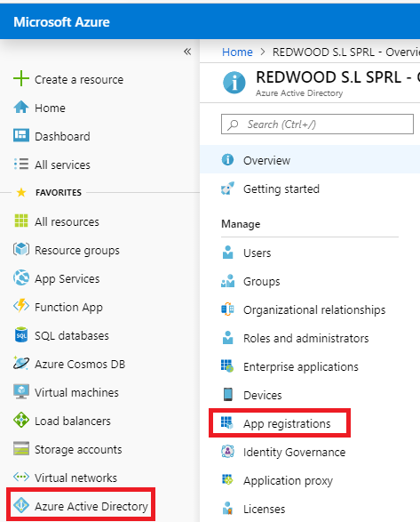

1. Click **New registration**:

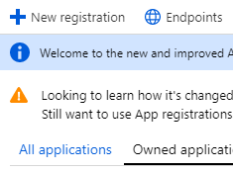

1. Name the application **FlowCreateTeam**:

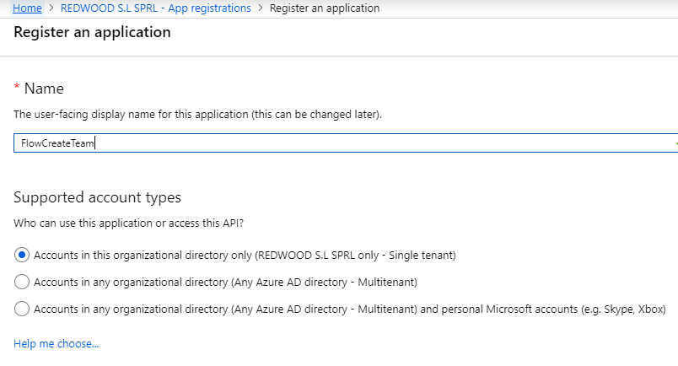

1. Click **Registe**r.
2. Now we will assign some permissions to this application.

Click **API permissions**:

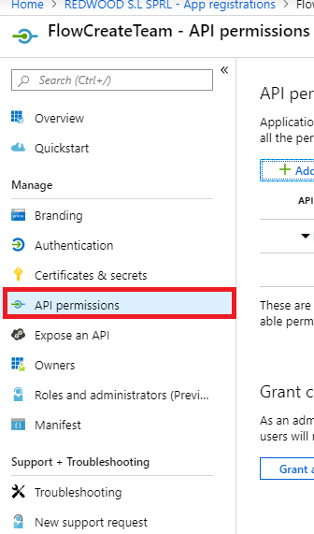

1. Click **Add Permission**
2. Select **Microsoft APIs**, click **Microsoft Graph**:

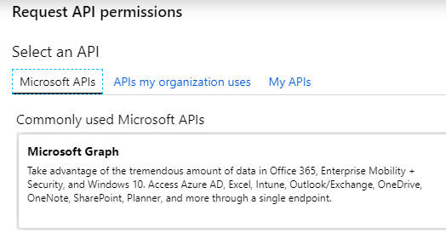

1. Choose **application permissions**.
2. In the Groups, select **Group.ReadWrite.All**:

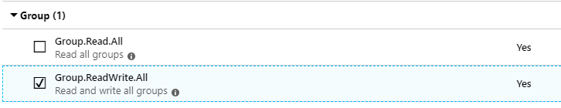

1. Click **Add permissions**
2. Follow the same steps to add the Directory permissions:

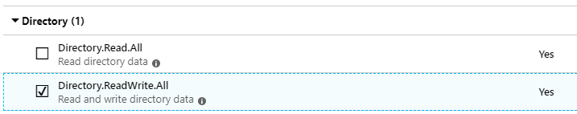

1. Click **Add permissions**
2. Click **Grant Consent for** <your tenant name>

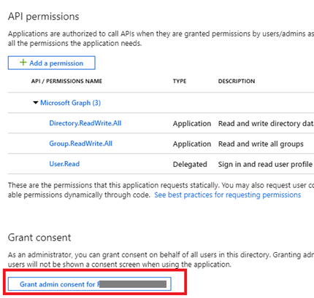

1. Confirm: yes.

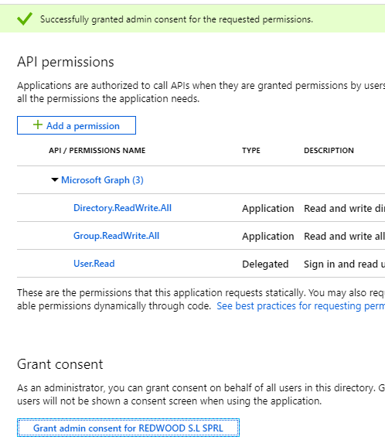

1. Go to the application panel and click **Certificates & secrets**:

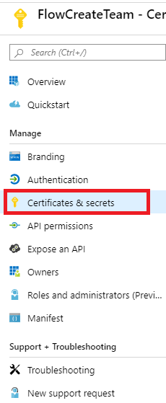

1. Click **New client secret**.
2. Fill in the secret form and select **Expires: Never**

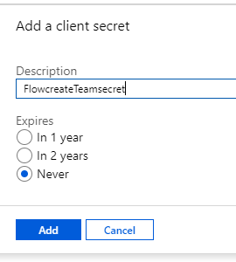

1. Click **Add**.
2. Copy the secret value in notepad.
3. Go back to **Overview**:

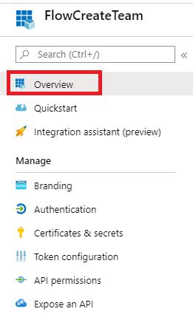

1. Copy the application ID and the Tenant ID into Notepad:

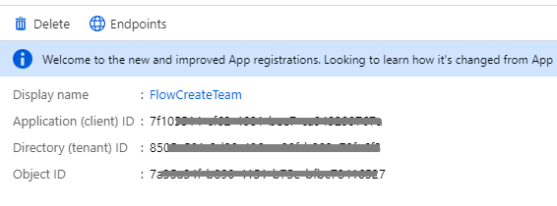

1. Create a Flow starting from a button, create 3 Compose actions Named **TenantID**, **ClientID,** and **SecretID** and store your values in these actions:

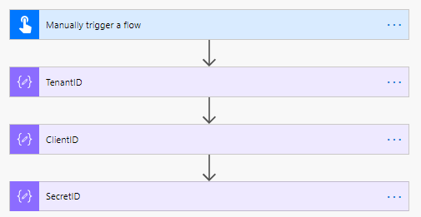

1. In the trigger define an input named **group name**:

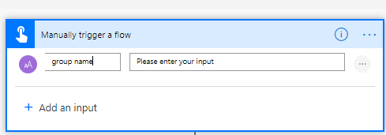

1. Add an HTTP (premium action and define its properties like this:

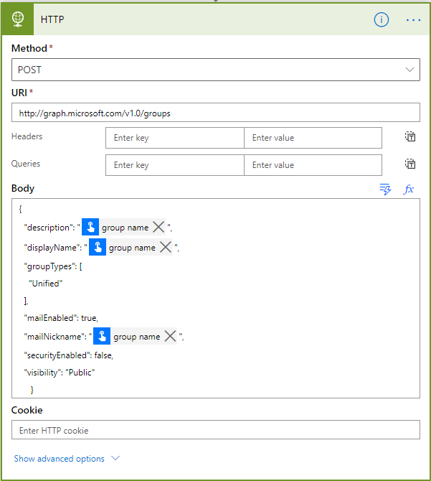

You can adapt the Body by reusing the following code:

{

"description": "",

"displayName": "",

"groupTypes": [

"Unified"

],

"mailEnabled": true,

"mailNickname": "",

"securityEnabled": false,

"visibility": "Public"

}

1. Click **Show Advanced options**.
2. For the **Authentication** field, select **Active Directory OAuth**.
3. Pass the TenantID, ClientID and SecretID
4. **Authority** should be: <https://login.microsoftonline.com>
5. **Audience** should be: <https://graph.microsoft.com>
6. Define the body as follows:

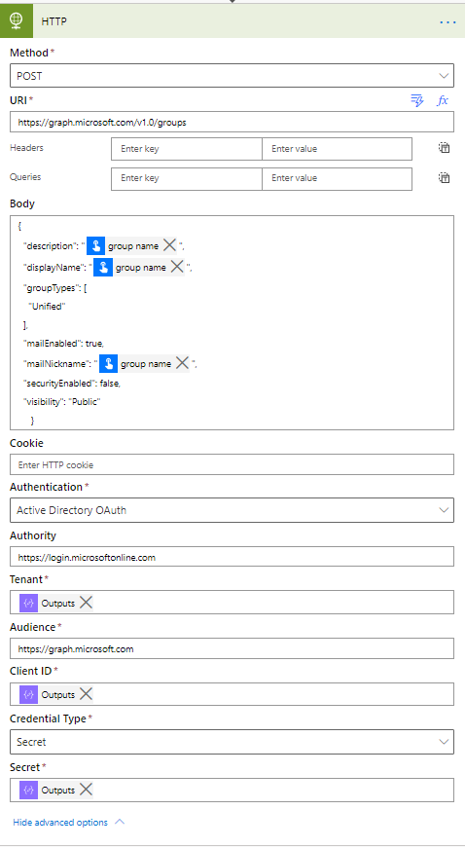

1. Rename the HTTP action to **Create Group**.
2. Save the Flow, run it, pass a group name (add your name in the group name to make sure it is unique)
3. Check the Azure Active Directory; your new group should have been created:

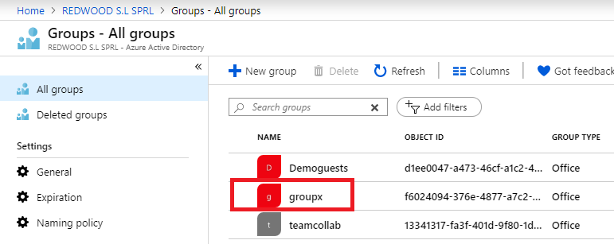

1. Add Compose action, rename it **GroupID** and grab the id value returned by the Create Group action:

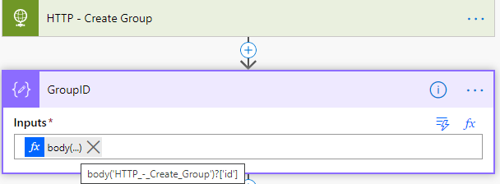

1. A group must have an owner; the owner will be the user starting the Flow. We must find his e-mail and its object id in AAD.
2. Add an action Get User Profile (V2) and define the expression to retrieve the current user e-mail address:

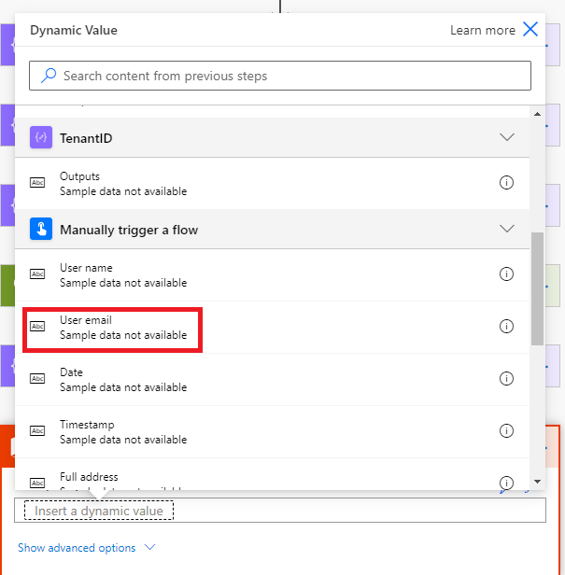

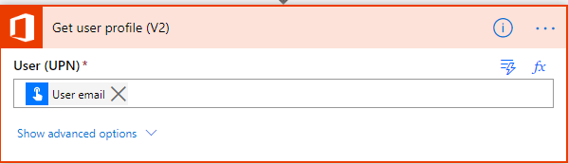

1. Add a Compose action, name it **OwnerURI** and use the following expression:

**concat(concat(**'https://graph.microsoft.com/v1.0/groups/',**outputs(**'GroupID'**))**,'/owners/$ref'**)**

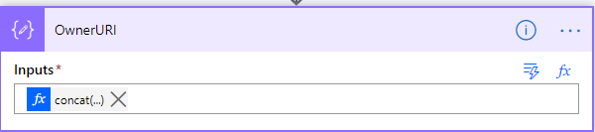

1. Add an **HTTP action** to add the owner to the group; in the body, pass the id field of the **Get user profile** action. Use the settings defined in our previous HTTP action (**secretID**, **tenantID**,…)

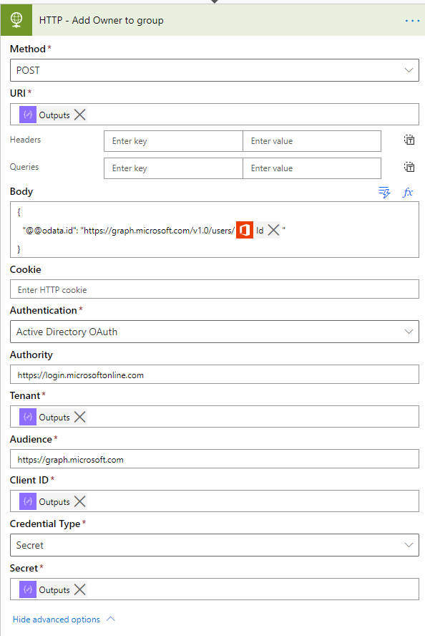

1. Use another HTTP action to create the Team, make sure the Method is PUT and pass the previous compose action Id value into the group URL.

You can adapt the Body by reusing the following code:

{

"memberSettings": {

"allowCreateUpdateChannels": true

},

"messagingSettings": {

"allowUserEditMessages": true,

"allowUserDeleteMessages": true

},

"funSettings": {

"allowGiphy": true,

"giphyContentRating": "strict"

}

}

}

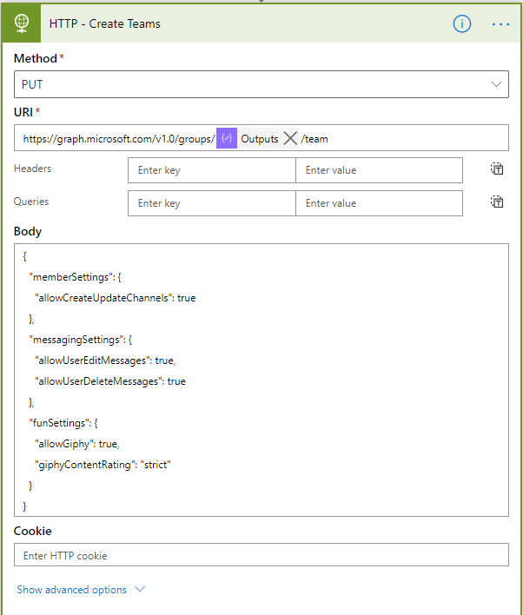

1. Run the Flow, pass a group/team name, and connect to <http://teams.microsoft.com> to check your team.

**We need your feedback**

Do you want to report an issue or to suggest something? We need your feedback: <https://github.com/Power-Automate-in-a-day/Training-by-the-community/issues>